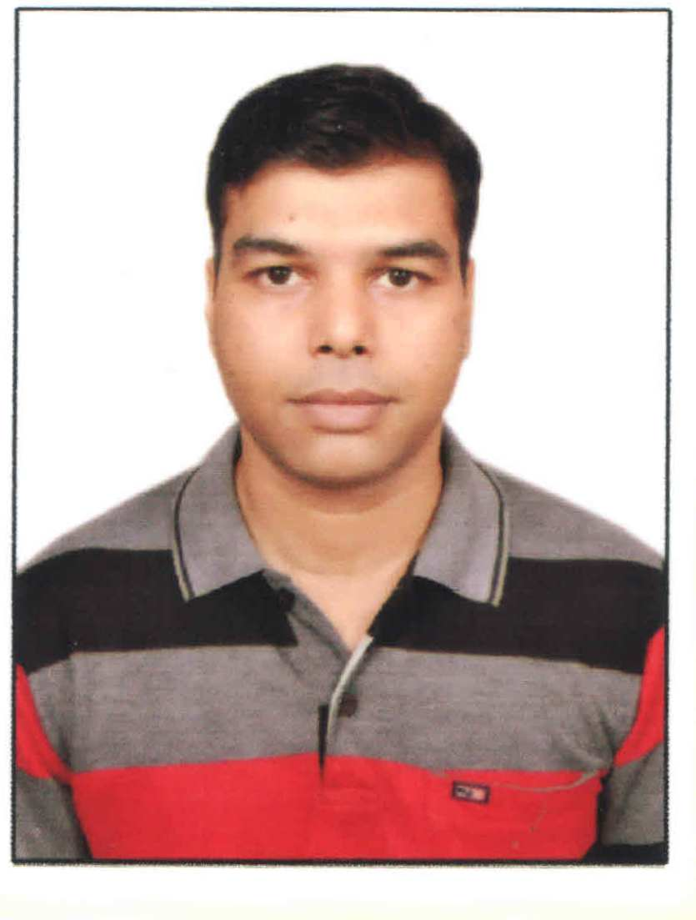  REETESH KUMAR MALAIYA  D-259, SECOND FLOOR, LAXMI NAGAR,  NEW DELHI-110092 | Mob. – 09555265559, 9971765814  e-mail:- reeteshmalaiya@yahoo.com  malaiya.reetesh@gmail.com
RESUME

CAREER OBJECTIVE:

To join a position of responsibility with a professionally managed progressive organization that provides conductive learning and development.

ACADEMIC PROFILE:

Course | Institution /University/Board | Pass out Year
M.B.A.  (Business Economics) | I.P.S. Academy  Indore / D.A.V.V. | 2007- 09
Bachelor in commerce | Dr. H.S. Gour Vishwavidyalaya, Sagar (M.P.) | 2004
Higher Secondary School | Govt Boys School,  Garhakota, Sagar (M.P.) | 2001
High School | S.S.M. School  Garhakota, Sagar(M.P.) | 1999

SUMMER TRAINING:

- In APEX BANK, BHOPAL (M.P.) on “Analysis of Financial Statements”.

EXPERIENCE:

- One year experience as a sales executive in Sandeep Trading Company, C&F Ghadi Detergent & Cake, Indore.
- One year experience as a Admin. Manager in Kaziranga Guest House, New Delhi.
- I am working as a Content Writer and Proof Reader for Hindi Books in part time basis at N.S. Enterprises, Gajendra Granthmala Publication, Delhi.
- Recently I am working as a Executive Assistant cum Assistant Admin Manager in Aduro Trading & Associates Pvt. Ltd. New Delhi, since 15 May 2011.

MY JOB PROFILE:

- Dealing with clients with phone calls and emails.
- Managing diaries and organizing meetings and appointments.
- Calendar management.
- Booking and arranging travel, transport and accommodation.
- Providing secretarial support.
- Travel for office anywhere as per requirement.
- Confidential documents maintenance.
- Maintain office as Admin manager.
- Supervise housekeeping team.
- Up to date all office infrastructures and generate good environment to employees.
- Monitor and coordinate with all services provider for office.
- Maintain all office equipment time to time.
- Informed and aware to MD for upcoming commitments and responsibilities.
- Discuss with CA about financial documents of company and MD. And proceed all time to time.

COMPUTER PROFICIENCY:

- M S Office Tools
- Tally ERP 9

LINGUISTIC FLUENCY:

- Hindi
- English

STRENGTH:

- Adoptability.
- Vision for learning, Honesty.
- High energy, sincere, punctual.

Extra Skills:
- Content Writing in Hindi
- Proof Reading for Hindi Books

HOBBIES:

- Reading Hindi Literature
- Play cricket & chess
- Listening music

PERSONAL PROFILE:

Gender : Male
Date of Birth : 14th August 1983
Nationality : Indian
Marital status : Married
Father’s name : Mr. Chandra Kumar Malaiya
Mother’s name : Mrs. Premlata Malaiya
Permanent Address : Near Choudhary Jain Mandir,
Tagore Ward, Garhakota, Sagar (M.P.)

DECLARATION:

I here by declare that above mentioned details are correct and complete to the best of my knowledge and belief.

Date : Yours Truly,

Place
REETESH KUMAR MALAIYA

